Directions: Use Graph A to evaluate the following.

$f(2)=$ _____ $\underset{x→4^{−}}{\text{lim}}f(x)=$_____ $\underset{x→2}{\text{lim}}f(x)=$_____

$\underset{x→4^{−}}{\text{lim}}f(x)=$_____ $\underset{x→1^{−}}{\text{lim}}f(x)=$_____ $\underset{x→1^{+}}{\text{lim}}f(x)=$_____ $\underset{x→1}{\text{lim}}f(x)=$_____

Directions: Use Graph B to evaluate the following.

$f(−1)=$_____ $\underset{x→3^{+}}{\text{lim}}f(x)=$_____

$f(2)=$_____ $\underset{x→2^{−}}{\text{lim}}f(x)=$_____ $\underset{x→2^{+}}{\text{lim}}f(x)=$_____ $\underset{x→2}{\text{lim}}f(x)=$_____

$f(1)=$_____ $\underset{x→1^{−}}{\text{lim}}f(x)=$_____ $\underset{x→1^{+}}{\text{lim}}f(x)=$_____ $\underset{x→1}{\text{lim}}f(x)=$_____

Does the$\underset{x→c}{\text{lim}}f(x)$exist at every constant c on the interval (2, 4)?

Does the$\underset{x→c}{\text{lim}}f(x)$exist at every constant c on the interval (-1, 1)?
Graph A
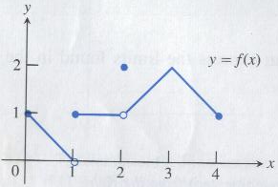

Graph B
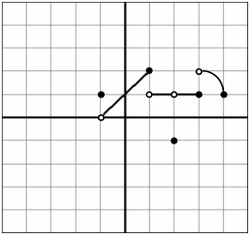

Directions: Evaluate the following limits.

$\underset{x→2}{\text{lim}}\left({\text{5x}}^{2}−7x+2\right)$ = _____ $\underset{x→−4}{\text{lim}} \frac{x^{2}−\text{16}}{x+4}=$_____ $\underset{x→4^{−}}{\text{lim}}\frac{\sqrt{x}−2}{x−4}=$_____

$\underset{x→7}{\text{lim}} \frac{x^{2}−\text{11}x+\text{28}}{x^{2}−5x−\text{14}}=$_____ $\underset{x→\text{-3}}{\text{lim}}\frac{\text{2x}+1}{x−3}=$_____ $\underset{x→−5}{\text{lim}} \frac{\sqrt{x+\text{13}}−\sqrt{8}}{x+5}=$_____

$\underset{x→−1}{\text{lim}}\frac{{\text{2x}}^{2}−x−3}{x+1}$= _____ $\underset{x→1}{\text{lim}} \frac{\sqrt{2x−1}−1}{x−1}$=_____

Directions: Use the given limit properties to evaluate the unknown limit.

Given $\underset{x→\text{-5}}{\text{lim}}\text{ f}(x)=8$, $\underset{x→\text{-5}}{\text{lim}}\text{ g}(x)=−3$, and $\underset{x→\text{-5}}{\text{lim}}\text{ h}(x)=1$. Evaluate $\underset{x→\text{-5}}{\text{lim}}[\text{5x}+g(x)$·$h(x)]$= _____

Given $\underset{x→4}{\text{lim}}\text{ f}(x)=−7$, $\underset{x→4}{\text{lim}}\text{ g}(x)=0$, and $\underset{x→4}{\text{lim}}\text{ h}(x)=5$. Evaluate $\underset{x→4}{\text{lim}}\left[\frac{h(x)\text{-g}(x)}{\text{2x}⋅f(x)}\right]=$_____

